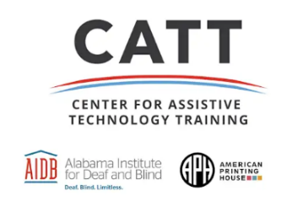
Fall PD Week 2026
Sept 24, 2026
Draft Agenda IN PERSON ONLY

8:00-8:30 Registration and Welcome

8:30-9:30 Monarch Overview and features

9:30- 9:45 Break

9:45-10:45 Hands-on with Monarch

10:45-11:00 Break

11:00- 12:00 Polly Overview and features

12:00- 1:00 Lunch

1:00- 2:00 Hands-on with the Polly and Helios

2:00-2:15 Break

2:15-3:30 Q&A

3:30 Adjourn

Your presenter:
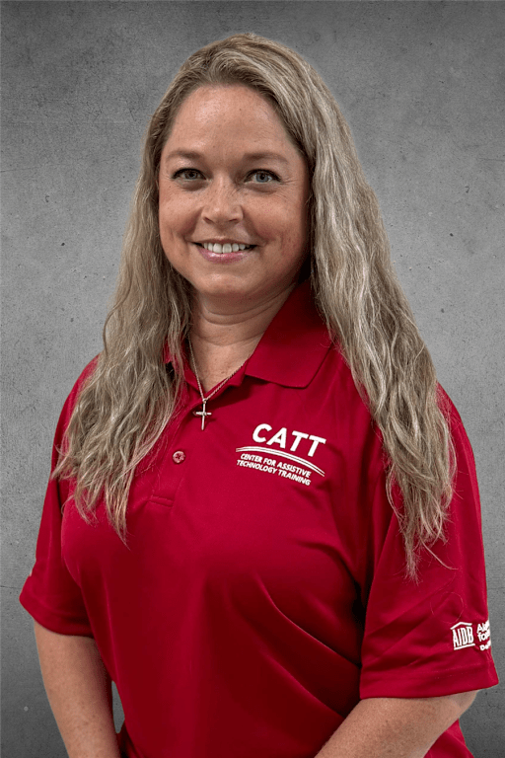
Jennifer Fuller, Trainer
Jennifer has been with AIDB for 10 years. Most recently she worked as a SPED classroom teacher at the Alabama School for the Blind. Jennifer is a certified TVI and obtained her Master’s degree in Collaborative Special Education. She also holds a Bachelor’s degree in Psychology, with a minor in Forensic Psychology. Jennifer is a wife of 23 years and has two sons and two dogs.

BS in Psychology- Post University Minor in Forensic Psychology- Post University MS in Collaborative of Special Education- UAB MS in Differential Education with a concentration in COMS/TVI-UAH

