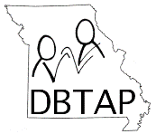

Haptics: Visual & Environmental Information
for Individuals who are Deaf-Blind

Presented September 12, 2019
In Conjunction with MO Deaf-Blind Project in St. Louis, MO

Presenters:
Mary Hale, Deaf-Blind Consumer
Beth Jordan, Helen Keller National Center
Anna Pitchford, Basic Certified Interpreter

Workshop Outline:
9:00am
- Welcome/Introductions
- Haptic Fundamentals & Structure
- Sharing Personal Reactions
- Directional Signals
- Reference Signals
- Levels & Grading
- Describing a Room
- Facial Expressions
- Action Signals
- Where Can I Learn More about Haptics?
- Evaluation/Workshop CheckPoints
4:00pm

