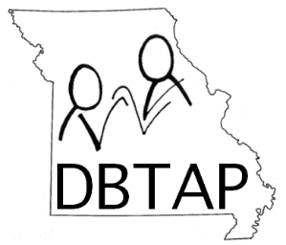**MISSOURI DEAF-BLIND TECHNICAL ASSISTANCE PROJECT (MoDBTAP)**

**MISSOURI SCHOOL FOR THE BLIND (MSB) OUTREACH**

**PRESENTS**

**DEAF-BLIND 101**

**Agenda**

|  |  |
| --- | --- |
|  |  |

**SEPTEMBER 11, 2019**

8:45 WELCOME/PRETEST

WHAT is DB/DUAL SENSORY LOSS? -MEGAN

HOW WE SEE/VISION-JANE

SIMULATION ACTIVITY

TYPE OF HEARING LOSS-MEGAN

10:00 Break

10:15 IMPACT ON COGNITION-KAREN

IMPACT ON COMMUNICATION-KAREN

IMPACT ON SOCIAL SKILLS-MEGAN

IMPACT ON ADAPTIVE SKILLS-MEGAN

11:15 CENSUS/ELIGIBILITY-MEGAN

11:45 BREAK/SET UP FOR LUNCH-SIMULATORS/PAIRS

12:00 LUNCH

1:00 HAND UNDER HAND-MANDY

WAIT TIME-MANDY

1:30 BALL ACTIVITY SIMULATION-MEGAN

1:45 USING CUES AND SYMBOLS-KAREN

DEMO-KAREN(TEACHER)/JANE (STUDENT)

SENSORY BOXES MEGAN/MANDY

2:30 CALENDAR SYSTEMS-KAREN/JANE

3:30 BREAK

3:45 INTERVENER IN ACTION-MANDY

4:00 COMPARISON OF INTERPRETER, INTERVENER/SSP-MEGAN

4:15 OUTREACH WEB PAGE RESOURCES

4:30 POST TEST/EVAL/DISMISS

**Your instructors:**

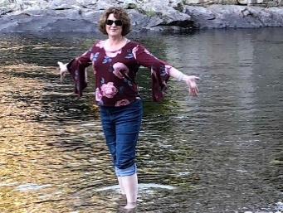 **Karen Carl** is a TVI at Fort Zumwalt School District. She has been working with the visually impaired since 1991. She has a BS Ed. in Elementary Education from the University of Missouri-Columbia, a M.Ed. in Specialized Reading and, a CTVI from University of Missouri-St. Louis, and a CTDB from East Carolina University. She also serves as an Educational Consultant with the Missouri Deaf-Blind Technical Assistance Project (MoDBTAP).

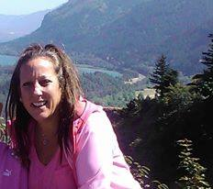**Jane Herder** is the Outreach Coordinator and Deaf-Blind Project Director for MSB Outreach Department. Jane has 23 years of experience as an Itinerant Teacher of the Visually Impaired and Orientation and Mobility Specialist in Missouri, Colorado and New Mexico. She received her Master of Education degree in Severe Needs: Vision Impairments and Orientation and Mobility and Multiculturalism from the University of Northern Colorado. She has an additional Graduate degree in Technology in Schools from UMSL. She is a Library of Congress Certified Braille Transcriber. Megan is on her last course to receive her graduate certificate in deafblindness from Texas Tech University.

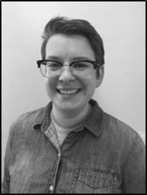**Megan Burgess** is the Deaf-Blind Project Coordinator for MoDBTAP at the Missouri School for the Blind Outreach Department. She has 11 years’ experience in behavioral health as a Recreational Therapist working with individuals who were hearing, hard of hearing, deaf and deafblind. Megan is a graduate of Southeast Missouri University, is a fluent ASL user and has completed the Interpreting Training Program at Florissant Valley Community College. Megan is on her last course to receive her graduate certificate in deafblindness from Texas Tech University.

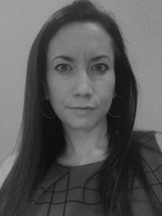**Mandy Clayton** comes to Outreach with 12 years prior experience as the Program Assistant at the South Carolina School for the Deaf and Blind. She currently is our Deaf-Blind School support specialist. Mandy coaches Missouri paraprofessionals/interveners and provides onsite TA to educational teams. She is the lead for VIISA, a professional development course for providers of infants, toddlers and youths with vision impairments with or without additional impairments. Additionally, Mandy directs our Family Involvement Fund and DB Kids Scholarships. Mandy is in her last course in the graduate certificate program in deafblindness with Texas Tech University.

|  |  |
| --- | --- |
|  |  |
|  |  |