2020 AER Scholarship

Applications are now being accepted for the 2020 AER Scholarship, which is awarded annually to three selected grad student applicants studying for a career in the field of Orientation & Mobility or Teachers of the Visually Impaired.

The three $2,000 scholarship winners will be announced in the Fall of 2020.

Deadline for submitting applications is August 31, 2020, and scholarship recipients will be notified on or around October 2020.

Eligibility Criteria:

- Graduate students enrolled in a master’s program or doctoral program are eligible to apply. Applicants must be studying for a career in the field of services of Orientation & Mobility or Teachers of the Visually Impaired.

- This scholarship is open to students located in the United States or abroad.

- Applications must be typed and submitted electronically to AER at michele@aerbvi.org.

- At least one letter of recommendation (no more than two) must be included with the application.

- The deadline for consideration for the 2020 Scholarship is August 31, 2020. All application materials must be in the AER office by that time.

To be considered for the 2020 AER Scholarship Award, all material must be received in full to AER by August 31, 2020. Applications must be submitted via email to michele@aerbvi.org.

If you have questions, please contact AER at 703-671-5875, 9:00 a.m. – 5:00 p.m., Eastern, or email michele@aerbvi.org.

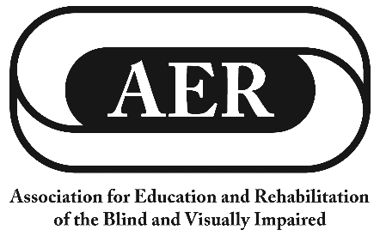

2020 AER Scholarship Application
Section I

- Personal Data

Name

Street Address:

City, ST ZIP:

Phone:

Email:

Date of Birth:

High School Graduation Date:

Preferred Contact Method:

2020 AER Scholarship Application
Section II

- Educational Background

- Current Educational Institution

Current Educational Institution:

Full Address:

Cumulative Grade Point Average:

Major:

Full or Part Time:

# of Hours:

Degree/Certificate Sought:

- List any other secondary or post-secondary schools you have attended

Previous Educational Institution:

Full Address:

Cumulative Grade Point Average:

Dates Attended (from-to):

Major:

# of Hours:

Degree Received and Date:

(Include additional information if you have attended additional secondary or post-secondary institutions.)

2020 AER Scholarship Application
Section III

- Additional Information

- Explain why you have chosen the field or course of study you are pursuing and whether you wish to work with children, adults or elderly persons who are blind or visually impaired.

B. In addition to information provided elsewhere on this application, please provide a brief autobiographical sketch, including a statement about your vocational goals, any work or volunteer experiences you may have had, major outside activities (school, church, community, sports, organizational, recreation, etc.), including the extent to which you played a leadership role, and any other details about your objectives which you feel are significant.

2020 AER Scholarship Application
Section IV - V

IV. Other Scholarships
Please list other scholarships which you have received and note date awarded. (Please note that preference will be given to qualified applicants who have not received other scholarships.)

V. References
Please include with this application at least one letter of recommendation (no more than two letters) from a teacher, professor, agency personnel, employer, or others whom you feel may provide more information about you and your qualifications.

2020 AER Scholarship Application
Section VI

VI. Verification of Application

Please provide the name and contact information of one person not related to you who can verify the information provided on this scholarship application.

Name:

Phone:

Email:

Relationship to this person:
(teacher, colleague, friend, etc.)

